Buddies Community Care Ltd

Medication And Medicine Management Policy And Procedure

Responsible Person: James Daniel Pay (Registered Manager)

For Escalation, Advice and Support: 07999 161718

1. Introduction
This policy replaces previous guidance on Home Care Support for Medicines Management in the Community. It provides clear guidance to all Buddies team members delivering medication support to adults in their own homes.
It ensures medicines are managed safely, in line with:
- Regulation 12: Safe care and treatment
- Regulation 13: Safeguarding service users from abuse or improper treatment
- Guidance from the National Institute for Health and Care Excellence (NICE)

2. Purpose
This policy applies to all Buddies team members and aims to:
- Promote safe and effective medication management
- Protect service users and staff from medication-related risks
- Ensure compliance with CQC regulations and NICE guidance
- Provide clear procedures for assessment, administration, recording, storage, and disposal of medicines
- Support competent, trained staff in safe practice

3. Organisational Roles
Registered Manager/ Nominated Individual: James Daniel Pay – responsible for medication governance, staff training, audits, and CQC compliance.
Care/ Support Staff (Buddies Team Members): Deliver medication support according to care plans, risk assessments, and MAR charts. (In due course an intermediary role may emerge, dependant on skills mix/ experience/ training whereby assessment of newer team members can be assessed safely by a Lead/ Senior care Worker – this will be defined and implemented in-line with good governance)

4. Medication Support Needs & Risk Assessment
- Encourage self-medication wherever safe
- Medication Assessment conducted by a qualified professional (RN, GP, MOP, or senior manager)
- Determine level of assistance:
Level | Description
a. | Prompt / verbal reminder only
b. | Assistance with preparation or delivery
c. | Full administration including MAR recording
Support options include:
- Community pharmacy consultation
- Family/friend support
- Community alarm or reminder service
- Compliance aids (blister packs, dosette boxes)
- ASC domiciliary care or community nursing support
- Advice from Medicines Optimisation Pharmacist (MOP) (most pharmacists can support for generic advice and can signpost appropriately, or flag for GP review who can make a specific referral to MOP or review as appropriate)

Risk assessment must reflect support level, risks, and time required for that particular activity (it is important that time frame is accounted for to ensure the appropriate/ care-planned approach and technique can be employed safely)

5. Providing Medication Support
- Care Staff must only provide support authorised in care plan or MAR chart (see appendix, or Log-my-care software as applicable.
- Administer only from original pharmacist-labelled containers
- Do not administer from containers filled by family/friends
- Report concerns or errors immediately to Registered Manager- if in doubt, do not administer – seek advice first.

Specialist Techniques:
- Rectal administration (e.g., diazepam)
- Insulin injections / blood glucose testing
- PEG administration
Only trained, competent (assessed specifically to the task and signed off by registered manager), authorised staff may perform these tasks

Consent & Capacity:
- Follow principles as set out in the Mental Capacity Act 2005
- Multi-professional assessment is required for users who lack capacity- including GP, Mental Health professionals, Social Worker
- Documented in care plan with regular review taking place and consideration of options ie informed omission, or covert administration (see below).

6. Administering Medication to Users Who Lack Capacity
- Follow care plan and MAR chart for all administrations

- PRN (as required) medications:
  - Must have clear criteria, maximum dose, and minimum intervals
  - Document administration on MAR chart
- Refusal is the service user’s right; do not force or disguise medications- otherwise than in accordance with an approved and formal covert medication plan.
- Escalate deterioration to Registered Manager in capacity for professional review-this will be duly forwarded to surrounding MDT/ Social Worker.

7. Controlled Drugs
- Follow legislation and pharmacy guidance for Schedules 2–4
- Record administration on MAR charts and within relevant section on CD book – dependent on agreed/approved method for recording
- Audit on each administration and escalate errors/ discrepencies to registered manager.

Common Controlled Drugs:
Schedule | Examples
2 | Morphine, Dexamphetamine, Diamorphine, Pethidine, Methadone, Methylphenidate, Fentanyl
3 | Buprenorphine, Midazolam, Temazepam, Pentazocine tablets, Tramadol, Phenobarbitone
4 | Diazepam, Zopiclone, Zolpidem
Always confirm advice from line manager when receiving any controlled drug

8. Storage of Medicines
- Responsibility lies initially with the service user; staff must assist and escalate concerns – where safety issues are identified seek advice from Registered Manager.
- Store away from heat, light, children; refrigerate if indicated
- Safe storage strategies for overdose risk must be recorded in care plan

9. Recording & MAR Governance
- Category 1 (prompting) – record in communication sheets
- Category 2 & 3 – record on MAR chart
- MAR charts will be audited regularly by Registered Manager
- Retainment of MAR charts for a minimum of 3 years (follow ICO guidelines)
- Follow incident reporting procedures for errors or untoward events

10. Disposal of Medicines
- Return to pharmacy when: course complete, expiry, medication stopped by GP/ prescriber or service user dies (retain for 7 days)
- Document disposal on MAR chart and care records
- Obtain verbal consent; record in care plan

11. Errors and Untoward Incidents
- Defined as mistakes in prescription, dispensing, administration, or storage
- Report immediately to Registered Manager, involve pharmacist/ GP
- Notify safeguarding authorities if abuse suspected

- Follow procedures for controlled drugs and serious incidents
- The Registered Manager will monitor national field safety reports and update team members and service user should there be any broader safety alerts relating to medication.

12. Training, Competence, and Monitoring
- Staff receive induction, supervised practice, and formal competency assessment – as well as specific training to support administration of unusual/ specialist medications where there is a need to do so
- Competence reviewed annually or sooner if concerns arise
- Maintain training and competency records in staff files
- MAR chart audits, incident reports, and supervision ensure ongoing governance / quality standards are being met.
- The registered manager is subscribed to government field safety notification service and will cascade information as needed.

13. References
- CQC Regulations 12 & 13: https://www.cqc.org.uk/guidance-regulation/providers/regulations-service-providers-and-managers
- Mental Capacity Act 2005: https://www.legislation.gov.uk/ukpga/2005/9/section/1
- NICE Guidance on Planning of Homecare- inclusive of medication management best practice: https://www.nice.org.uk/guidance/ng21/chapter/Recommendations#planning-and-reviewing-home-care-and-support

End of Policy Statement
This policy will be reviewed regularly to ensure it remains compliant with current legislation, regulatory standards, and best practice guidance.
The policy is subject to annual review, or sooner if there are:
  - Changes to relevant legislation or regulation
  - Guidance updates from the CQC or other regulatory bodies
  - Changes in organisational structure or service provision
  - Findings from internal audits or quality assurance processes
  - Feedback from staff, service users, or stakeholders
All staff are responsible for ensuring they are familiar with this policy and apply it consistently in their roles. Updates will be communicated to all relevant personnel, and training will be provided as necessary.

Policy Review and Version Control
Version | Date Issued | Reviewed By | Next Review Due | Changes Made (Summary)
1.0 | 07/03/2026 | James Pay | 07/03/2027 | Initial version issued

Approval:
Policy approved by: James Daniel Pay - Registered Manager
Signed: ................................. Date: 07/03/2026

Document Control:
- This document is a controlled policy. Once printed or downloaded, it becomes an uncontrolled copy and may not reflect the latest version. Please refer to the master version stored on the [policy management system / office file / care management software] for current policy.

APPENDICES

EXAMPLE MAR CHART (TO BE USED WHERE ELECTRONIC MAR IS UNAVAILABLE)
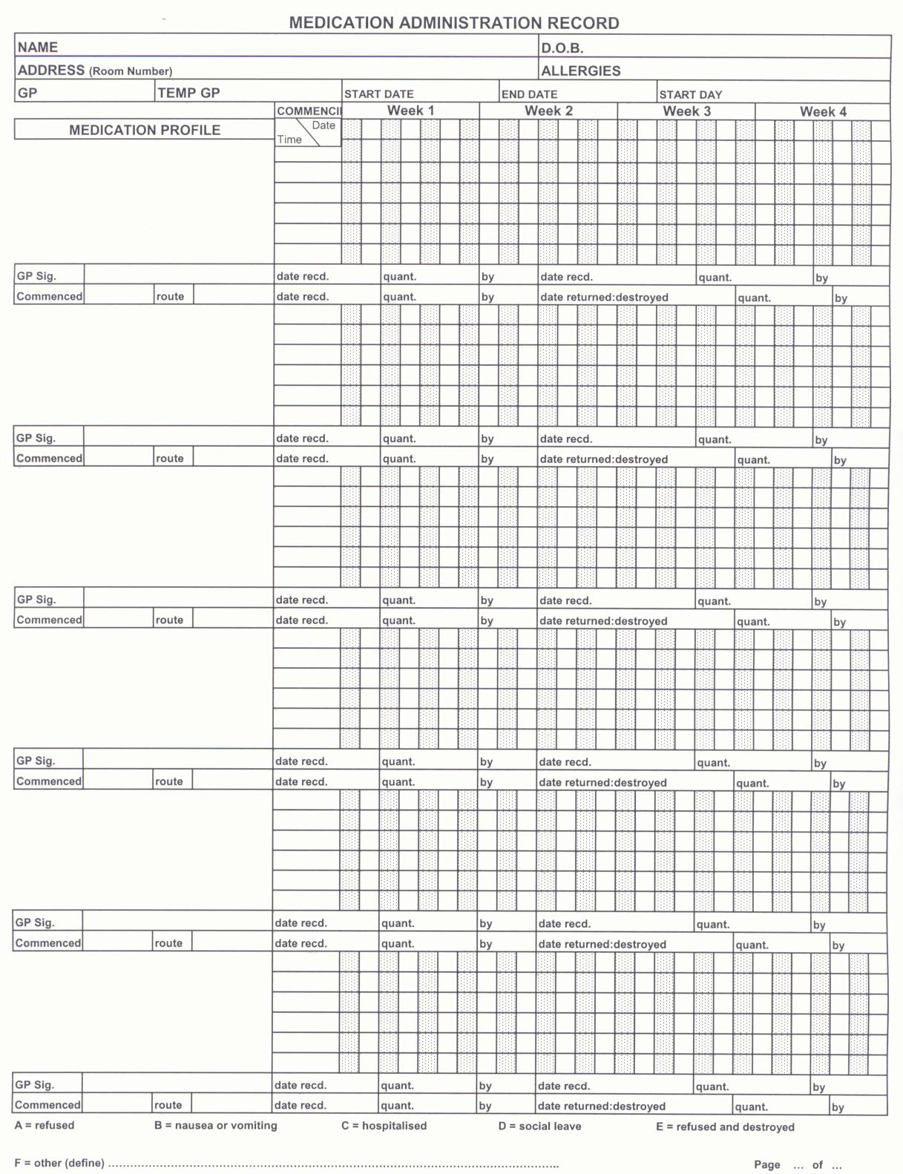

EXAMPLE SIGNATURE RECORD SHEET
To be completed by any member of staff who administers medication or is involved with the completion of a MAR sheet.
DATE | NAME | SIGN NAME | INITIALS
SPECIAL DOSAGE INSTRUCTIONS WARFARIN
For Service Users who are prescribed Warfarin, there must be a personal plan in place. The Service User should receive written and verbal information regarding the Warfarin treatment which should be reviewed and updated regularly.
The Service User must have received a “Yellow Book” (Oral anticoagulation therapy: Important information for patients) and this must be updated when INR3 monitoring tests are undertaken and will state when the next monitoring is due. (Updating the Yellow book will be done by the GP Practice or the Warfarin Clinic.)
The Service User will have their INR checked regularly and the dose of Warfarin will be altered accordingly by the managing clinician. To ensure that these changes are documented correctly on the MAR chart it is important that there are robust communication links between the GP Surgery, the Community Pharmacy, the Service User (or the Home Care Manager if administering on behalf of Service User) and the GP or local Anti-coagulation clinic who are undertaking the monitoring if appropriate.
The Community Pharmacy must ensure that INR monitoring has been undertaken prior to dispensing a prescription for Warfarin. All changes in dose should be confirmed in writing by the prescriber (or in the yellow book).
It is recommended that Warfarin is administered from an original pack dispensed for the individual patient. The use of monitored dosage systems or dosette boxes is not generally recommended for Warfarin as these systems are not flexible enough to facilitate frequent dose changes. NB. The typical range of dosage tablets are 1mg, 3mg & 5mg all are different colours and often an individual may have the full range of tablets prescribed to them.
The Community Pharmacy will dispense Warfarin as per prescription; if the prescription is dispensed during the month and there is a change of dose, a new MAR Chart must be produced.

Care staff should administer in accordance with the MAR chart instructions. If there are any queries or problems with a Service User on Warfarin, with regards to their medication and the MAR Chart, Care staff must contact their manager/supervisor immediately for further information. The Home Care Manager should in turn contact dispensing pharmacist or GP practice for advice.
If the Service User requires dental treatment, they may need a blood test up to 72 hours prior to this and the dentist should be contacted at least 3 days prior to the treatment.
Further information is available at http://www.npsa.nhs.uk/nrls/alerts-and- directives/alerts/anticoagulant/
QUICK GUIDANCE AFTER A NEEDLESTICK OR BODY FLUID CONTAMINATION ACCIDENT
Needlestick or sharps injuries occur when a needle or other sharp instrument accidentally penetrates the skin. This is called a percutaneous injury. If the
needle or sharp instrument is contaminated with blood or other body fluid, there is the potential for transmission of infection, and when this occurs in a work context, the term occupational exposure (to blood, body fluid or blood-borne infection) is used.
When blood or other body fluid splashes into eyes, nose or mouth or onto broken skin, the exposure is said to be mucocutaneous.
The risk of transmission of infection is lower for mucocutaneous exposure than for percutaneous exposures. Other potential routes of exposure to blood or other body fluids include bites and scratches.
First aid should be carried out immediately following the exposure. The first aid procedure is detailed as follows:
1) Wash the area liberally with water without scrubbing (ensure contact lens are removed in the case of splash to eyes)
2) In the case of a needlestick injury, encourage the area to bleed gently (but do not suck the wound)
3) Dry the area and in the case of percutaneous injury (needlestick, scratch or bite) cover with a waterproof dressing.
Following first aid measures, care staff should contact their manager/supervisor immediately for advice on the follow-up required.

COMMON CONTROLLED DRUGS
Schedule 2: CD Morphine
Dexamphetamine
Diamorphine
Pethidine
Methadone
Methylphenidate
Fentanyl
Pentazocine injection
Schedule 3: CD Buprenorphine
Midazolam Temazepam Pentazocine tablets Tramadol Phenobarbitone
Schedule 4: CD Diazepam Zopiclone Zolpidem
Example Brand names
Zomorph
MST
Sevredol
Oramorph Concentrated oral solution
100mg/5ml *
MXL Cyclimorph Dexedrine
Physeptone
Ritalin
Matrifen, Durogesic Fortral
Brand names
Temgesic (tablets) Butrans (patches) Hypnovel,

Fortral
THIS LIST IS NON EXHAUSTIVE – ADVICE SHOULD ALWAYS BE SOUGHT IN ANY INSTANCE WHEN RECEIVING A DRUG/MEDICATION FROM LINE MANAGER.

